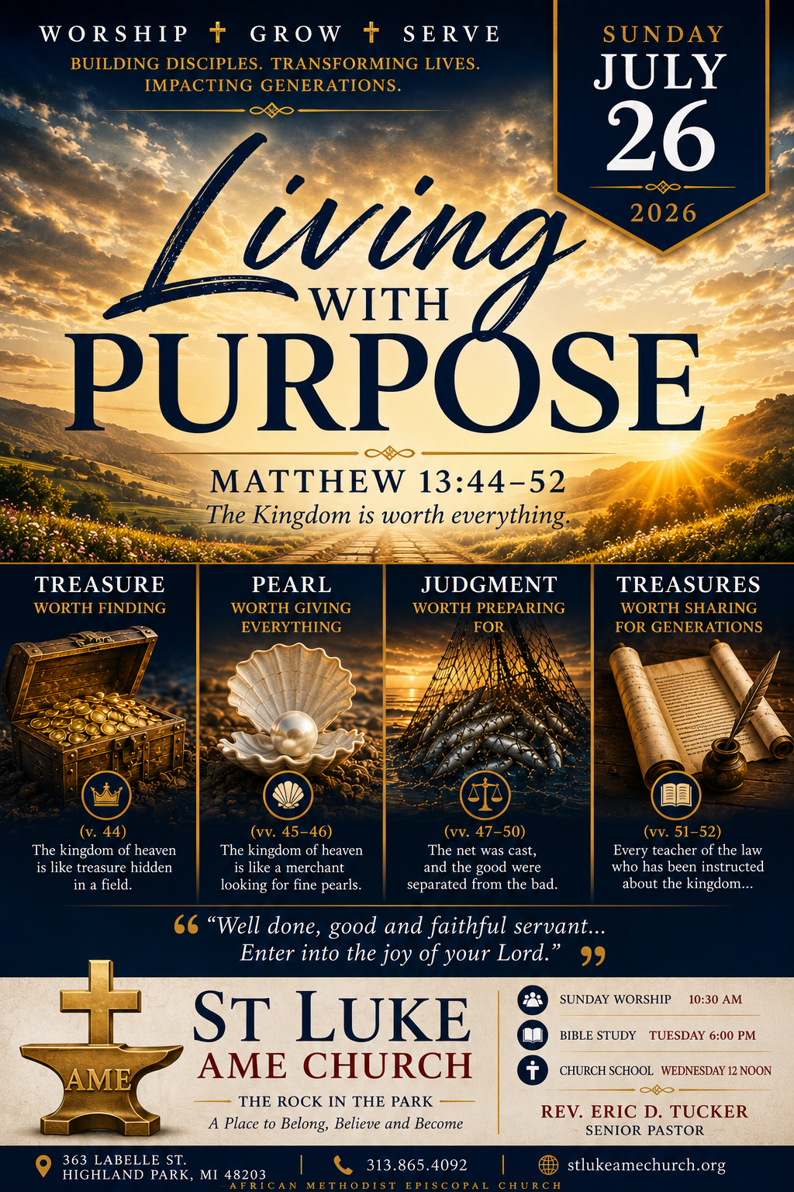
Rev. Eric D. Tucker, Pastor
July 26, 2026
Praise and Worship ……………………………………….………………………….….Bro. William Richardson
Call to Worship ………………………………..………………………..…………………………..… Pulpit Staff
Congregational Hymn ………………………….…………………………..………….…What A Fellowship#526
Invocation ………………………………….……………………..........................................................Pulpit Staff
Decalogue………………………………………….…………………………………….………...…...Pulpit Staff
Song of Praise ….....................................................................................................…………….…Music Ministry
Announcements/Acknowledgements/Visitors/Fellowship………...…………………………Voice of Hospitality
Remarks…………………………………………………….………………………………………......Pulpit Staff
Moment of Meditation……………………………………………….……………………………..…Pulpit Staff
Song of Praise …………………………………………………………………….……………….Music Ministry
Preached Word……….…..………………………..Matthew 13:44-52………….……….………………....Pastor
Invitation to Christian Discipleship………………………….……………...…………………………….…Pastor
Tithes and Offering………………………….…………ZELLE: STLUKEAMEHPMI@GMAIL.COM, Givelify
Benediction……………………………...………………………………………………………………...…Pastor
Order of Service is subject to change by direction of the Holy Spirit

REMEMBER OUR CIRCLE OF HEALING WITH YOUR PRAYERS, PHONE CALLS, CARDS AND WELL WISHES
Pastor Tucker & Family, Sis. Dell Alston, Sis. Mary Barclay-Burton, Sis. Carla Partee, Sis. Vivian Mouzon, Josephine Peoples, Sis. Rhonda Turnbull, Sis. Ruthie Maples & Family, Sis. Addie Anderson & Family, Bro. Reggie McKenzie, Bob Bennett, Don Curton, Evin Curtin (Don’s son), The Family of Sarah Long, Joclyn Andres (LaRico’s wife) and the entire St Luke Family.

WiFi NETWORK NAME: The Rock PASSWORD: Rockinthepark363!



PASTOR’S BIBLE STUDY
Tuesdays @ 6:00 pm
Meeting ID: 893 3287 1160, Passcode: 683458
Dial in: (307)751-8592
CHURCH SCHOOL w/ Sis. Barbara Porter
Wednesdays @ 6:00 pm
CONFERENCE LINE: 1(605)313-5395, PASSCODE:202509#

Announcements

HAPPY BIRTHDAY TO ALL FOR THE MONTH OF JULY

-We are honored and delighted to have the Littles Family Reunion worshiping with us today. We pray that your time with us is meaningful, uplifting, and inspires you to worship with us again.
-The 140th Session of the Michigan Annual Conference will be held August 19–22, 2026, at the Marriott Centerpoint in Pontiac, Michigan. The conference will be hosted by Newman AME Church, under the leadership of Rev. Yolanda Whiten. Please keep our Bishop, Supervisor, clergy, delegates, and the entire Michigan Conference in prayer as we gather under the theme, “Think Possible!”
-The media team is preparing to make interview videos with members to promote our church anniversary. Be prepared to tell your story about why you are at St Luke.
-Friends and Family Picnic Fellowship. Pastor Keith Pugh and the Greater St. Matthew Church family have invited St. Luke AME Church to join them for their Friends and Family Picnic on Sunday, August 23, 2026. Let us come together for a wonderful time of food, fun, fellowship, and Christian love. Please invite a family member, friend, neighbor, or coworker to join us as we fellowship together! Additional details will be shared soon.
-Our Church Conference will be held on Sunday, August 9, 2026, immediately following the worship service. Please mark your calendars and come prepared to present your organizational reports and provide an update on plans for the Church Anniversary.
-On the back of the bulletin, there is a QR code that will take people directly to the website. Please pass it along to get more traffic to the website.
St Luke Website QR Code



