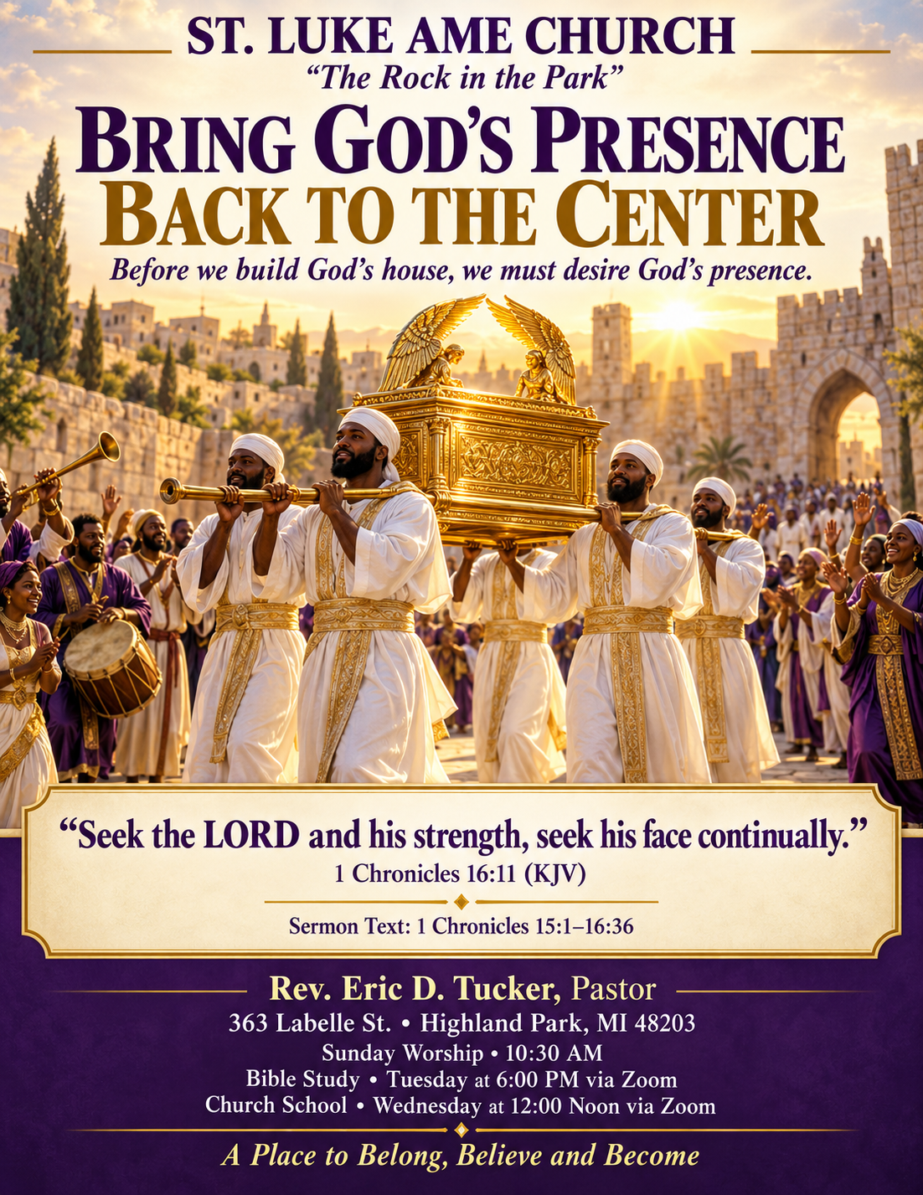

Eric D. Tucker, Pastor
October 18, 2026
Praise and Worship ……………………………………….………………………….….Bro. William Richardson
Call to Worship ………………………………..………………………..…………………………..… Pulpit Staff
Congregational Hymn ………………………….………………………..…………......………Pass Me Not #272
Invocation ………………………………….………………………......................................................Pulpit Staff
Decalogue………………………………………….…………..……………………….………………Pulpit Staff
Song of Praise …….................................................................................................…………….…Music Ministry
Announcements/Acknowledgements/Visitors/Fellowship………..…….……………………Voice of Hospitality
Remarks………………………………………….……….…………..………………………………...Pulpit Staff
Song of Praise …………………………………………………………………….……………….Music Ministry
Preached Word…………………………1 Chronicles 16:10-11………..………………..……….….……Pastor
Invitation to Christian Discipleship………………………….……………….……………...………………Pastor
Tithes and Offering………………………….…………ZELLE: STLUKEAMEHPMI@GMAIL.COM, Givelify
Benediction……………………………………………………………………………………..….………Pastor
Order of Service is subject to change by direction of the Holy Spirit
REMEMBER OUR CIRCLE OF HEALING WITH YOUR PRAYERS, PHONE CALLS, CARDS AND WELL WISHES
Pastor Tucker & Family, Sis. Dell Alston, Sis. Mary Barclay-Burton, Sis. Carla Partee, Sis. Vivian Mouzon, Josephine Peoples, Sis. Rhonda Turnbull, Sis. Ruthie Maples & Family, Sis. Addie Anderson & Family, Bro. Reggie McKenzie, Bob Bennett, Don Curton, Evin Curtin (Don’s son), The Family of Sarah Long, Joclyn Andres (LaRico’s wife), Felicia Stone, Mouzon Owens and the entire St Luke Family.

WiFi NETWORK NAME: The Rock PASSWORD: Rockinthepark363!

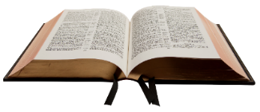

PASTOR’S BIBLE STUDY
Tuesdays @ 6:00 pm
Meeting ID: 893 3287 1160, Passcode: 683458
Dial in: (307)751-8592
CHURCH SCHOOL w/ Sis. Barbara Porter
Wednesdays @ 6:00 pm
CONFERENCE LINE: 1(605)313-5395, PASSCODE:202509#
Announcements

HAPPY BIRTHDAY AND ANNIVERSARY TO ALL FOR THE MONTH OF OCTOBER
-New Grace Missionary Baptist Church and St Luke AME Church, in partnership with University of Michigan Health Community Health Services, will host a Free Flu Vaccine Clinic on Saturday, November 7, from 11:00 a.m. to 3:00 p.m. The clinic will be held at 25 Ford Street, Detroit, Michigan 48203. Free flu vaccines will be available for adults 18 years of age and older. This is a wonderful opportunity to protect yourself and your family as we enter flu season. We especially encourage seniors, those with chronic health conditions, caregivers, and anyone who may not have medical insurance to take advantage of this free community health service.

-🎉 108 YEARS — AND GOD IS STILL FAITHFUL! 🎉St. Luke AME Church — “The Rock in the Park” is preparing to celebrate 108 years of faith, worship, ministry, and service! Join us on Sunday, November 15, 2026, at 4:00 PM for our 108th Church Anniversary Celebration Service! 🔥 Our special anniversary preacher will be Bishop V. Ricardo Thomas of Faith Tabernacle Church in Highland Park! For 108 years, God has kept us, sustained us, and used St. Luke to be a light in this community—and we believe the best is still ahead! 💝 We are asking each member to give a celebratory gift of $108.00 in honor of our 108th Church Anniversary—one dollar for each year of God’s faithfulness! Let’s give with grateful hearts as we celebrate our heritage and support the ongoing ministry of St. Luke. Save the date, spread the word, and get ready to CELEBRATE! 📅 Sunday, November 15, 2026⏰ 4:00 PM There are flyers to be distributed. Tell one, tell all what is happening at the ROCK!

-The Fourth Episcopal District’s 2026 Planning Meeting will be held October 22–24 at the Sheraton Hotel Keystone at the Crossing in Indianapolis, Indiana. Rooms are $179 per night, with complimentary parking. The hotel reservation deadline is September 29. For more information, please contact the Fourth District Office at 773-955-9825.

-Today, we are wearing pink in celebration of Breast Cancer Awareness Month! At St. Luke AME Church, our pink represents hope, love, and unity as we celebrate survivors, support those still in the fight, honor families touched by breast cancer, and remember those we have lost. We wear pink to remind one another that no one walks this journey alone!

-🌻 St. Luke, We Need Your Helping Hands! 🌻 Our Enchanted Garden community celebration is coming Friday, October 30, 2026, from 6:00–8:00 PM, at 363 Labelle St., Highland Park—and we need YOU! Help us create a welcoming evening where faith, family, and fun grow together! We’re looking for volunteers to decorate trunks and distribute candy, lead games, assist with the costume parade and family photos, welcome guests, and help with setup and cleanup. Whether you can give a little time or serve throughout the evening, your participation will help make this FREE family and community event special for our children and neighbors. Please let Sister Valerie Williams know how you would like to help. Let’s show our community the love of St. Luke—one smile, one treat, and one helping hand at a time!

-Join St. Luke AME Church — “The Rock in the Park” for an inspiring afternoon of faith, fellowship, and encouragement featuring God With Us!📅 Saturday, November 14, 2026⏰ 3:00 p.m.📍 MJR Theatre in Troy, Michigan🎟️ Cost: $30 per person, including your movie ticket, medium popcorn, and drink. Please submit your down payment by October 25th and your remaining balance by November 1st. We pray you have taken a moment to watch the movie trailer and share it with your family and friends. Invite someone to join us as we enjoy this special outing and support the ministry of St. Luke! Thank you for your participation and support! The Steward Board
-If you would like to add your birthday and wedding anniversary announced on our calendar, please email to Sis. Kim Holt. (kholt0123@gmail.com) Thank you!

SUNDAY SCHOOL REFLECTIONS FOR 10-18-26 JUDGES 3:15-23, 30
When you think of judges, what comes to mind? Today, we think of judges as
individuals who preside over courtrooms and administer justice. However, in the
book of Judges, these individuals were primarily deliverers or rescuers chosen by
God to free the Israelites from their enemies and oppressors.
During this period, the Israelites found themselves caught in a repeated cycle of
disobedience. They would turn away from God, worship idols, and do what was
evil in His sight. As a result, God would allow them to fall under the oppression of
their enemies. Eventually, they would cry out to God for help, and in His mercy,
He would raise up a judge to deliver them. For a while, the people would return to
God and live in peace. But after the judge died, they would forget God, return to
their sinful ways, and the cycle would begin all over again.
In today’s lesson, we see this cycle repeated once again. The Israelites did what
was evil in the eyes of the Lord, and God allowed King Eglon of Moab to oppress
them for eighteen years. Eglon is described in Scripture as a very fat man. After
years of suffering, the Israelites cried out to God for help, and once again, God
heard their cries and raised up a deliverer named Ehud.
Now, Ehud was a left-handed man, and this detail is important because it played
a significant role in how he would carry out his plan to deliver Israel. Ehud made
a double-edged dagger, about a foot long, and strapped it to his right thigh,
concealing it beneath his clothing.
Ehud was sent, along with others, to deliver Israel’s tribute payment to King
Eglon. After presenting the tribute and leaving, Ehud turned back and told the
king that he had a secret message for him. When Ehud said the message was
from God, the king rose from his seat. Ehud then reached with his left hand, drew
the dagger from his right thigh, and plunged it into the king’s belly. The dagger
went in so deeply that even the handle disappeared beneath the king’s fat.
Afterward, Ehud closed and locked the doors of the upper room and escaped
before anyone realized what had happened. By the time the king’s servants
discovered that something was wrong, Ehud was long gone.

But Ehud’s mission did not end with the death of King Eglon. He returned to rally
the Israelites and led them into battle against the Moabites. With God’s help,
Israel defeated approximately ten thousand Moabite soldiers, and Moab was

brought under Israel’s control. Scripture tells us that the land then enjoyed peace
for eighty years.
What can we learn from today’s lesson?
One important lesson is that God is merciful, even when His people repeatedly
fail Him. The Israelites continued to turn away from God, yet when they sincerely
cried out for help, He heard them and provided a way of deliverance.
Another lesson is that God can use unexpected people and unusual
circumstances to accomplish His purpose. Ehud’s left-handedness, something
that may have seemed insignificant, became an important part of his strategy. It
reminds us that God can use the abilities and characteristics He has given us in
ways we may never imagine.
Finally, this lesson challenges us to examine our own relationship with God. Are
we sometimes like the Israelites, turning to God when we are in trouble but
forgetting Him when things are going well? Our faithfulness to God should not
depend on our circumstances. We are called to trust and obey Him in both good
times and difficult times.
Questions for Reflection and Discussion:
1. Is it easier to remain faithful and obedient to the Lord when we are part of
a group, or when we must stand alone? Why?
2. Ehud used a carefully planned and cunning strategy to defeat King Eglon.
Is it ever appropriate for Christians today to use cunning or strategic
thinking to accomplish a goal?
3. Where should we draw the line between wisdom and deception?
Next Week’s Lesson: Judges 17:1-6; Judges 18:18-19, 27

Summary Reflection — Bringing God’s Presence Back to the Center
1 Chronicles 15:1–16:36
David’s return to the task of bringing the Ark to Jerusalem reminds us that spiritual growth requires a willingness to learn. After the painful failure of his first attempt, David acknowledges what went wrong and follows God’s instructions. His example encourages us: our mistakes do not have to end our journey, but receiving correction should change how we move forward.
As the Ark enters Jerusalem, reverence and joy come together. The people honor God’s holiness while celebrating His goodness. David joins them in worship, reminding us that everyone—from leaders to those serving quietly behind the scenes—has a place in honoring the Lord. Our expressions may differ, but our hearts should share the same focus.
The celebration also leads to generosity and continuing thanksgiving. David blesses the people, shares food, and appoints those who will keep praising God. Worship reaches beyond a single service. It should shape how we care for others, remember God’s faithfulness, and live throughout the week. Even in difficult seasons, we can give thanks for His sustaining love while honestly bringing Him our needs.
For St. Luke, this lesson invites us to examine what guides our ministry. As we maintain our building, plan programs, and celebrate our history, are prayer, Scripture, and love shaping our decisions? In our personal lives, are we making room for God to correct our habits and direct our priorities?
Before we build God’s house, we must desire God’s presence. May our desire for Him deepen our worship, strengthen our obedience, and make our church a place where people experience His love.
Is God’s presence truly at the center of what we’re building?
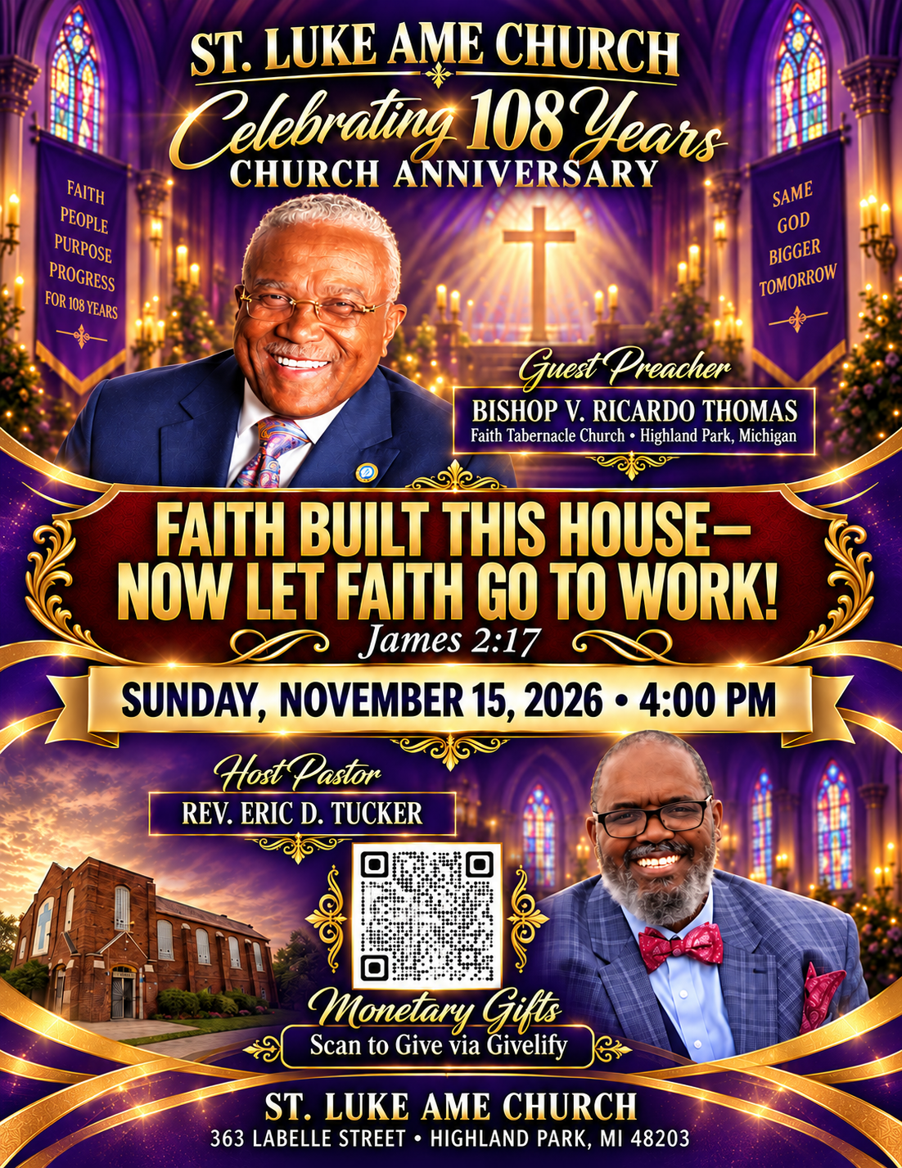




St Luke Website QR Code



